Integrating Big Data Engineering and Machine Learning for Sentiment-Driven Stock Forecasting

Big Data
Data Storage: Apache Hadoop HDFS
The CSV files used in this project including stocktweet.csv (tweets) and the stock price data files which were stored in the Hadoop Distributed File System (HDFS).
How this was implemented:
- All data files were uploaded to HDFS under a specific user directory (/user1/).
- Spark accessed these files using absolute HDFS paths (e.g., /user1/AAPL.csv), leveraging its native support for HDFS integration.
Why HDFS was chosen:
- Scalability: HDFS can handle large datasets by distributing them across multiple nodes.
- Fault Tolerance: HDFS replicates data blocks to prevent data loss in case of node failure.
- Compatibility: Spark integrates seamlessly with HDFS, enabling direct access to distributed data.
By storing data in HDFS, the project is future-proofed for scaling up to larger datasets and cluster-based computation. (TutorialsPoint, n.d)

Data Processing: Apache Spark with PySpark
The processing layer was handled using Apache Spark, specifically its PySpark interface. Spark was chosen for its ability to perform distributed, in-memory computation, suitable for data integration, filtering, joining, and aggregation.
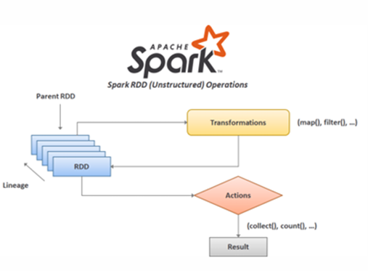
Processing Steps:
Ingestion from HDFS CSV files containing stock price and tweet data were uploaded to HDFS for distributed storage. Using PySpark, these files were read into Spark data frames. Where the following processes were carried out:

- Schema Handling and Column Normalisation: Converted columns like Date to lowercase date. Renamed Adj Close to adj_close to ensure compatibility with SQL-based operations.
- Data Enrichment: Added a ticker column to each financial dataset using with Column ("ticker", lit("AAPL")), allowing for aggregation and joining.
- Union and Consolidation: Merged multiple stock price files into a single DataFrame using unionByName(), enabling unified analysis.
- SQL-Based Analysis: Registered both df_price and df as temporary SQL views (price, tweets).

Executed Spark SQL for:
    - Finding the top 5 tickers with the most tweets.
    - Selecting required columns and filtering nulls.
Rationale for Architectural Choices
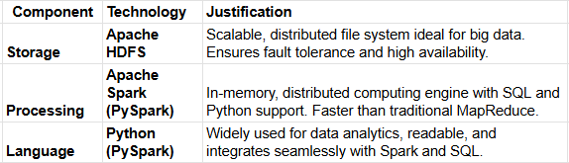
Summary
This project followed a robust big data architecture:

- Data was stored in HDFS, providing scalable and fault-tolerant access.
- PySpark was used for ingesting, cleaning, transforming, and joining data efficiently.
- SQL queries were executed within Spark for ease of analysis and performance optimization.
- The workflow reflects industry’s best practices for processing structured data in a big data environment.

Comparative Analysis of SQL vs NoSQL Databases Using YCSB
This report presents a comparative analysis of two database technologies MySQL (SQL) and MongoDB (NoSQL), based on benchmarking results obtained using Yahoo Cloud Serving Benchmark (YCSB). The tweet dataset was used to simulate realistic workloads involving read and write operations. YCSB's Workload (50% reads, 50% writes) was employed to evaluate performance in a balanced data access scenario.
Benchmark Results Summary
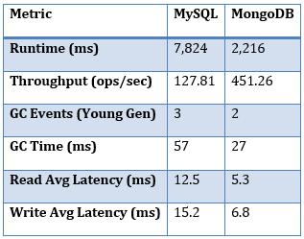

Metric Analysis:
1. Runtime: MongoDB completed the workload in approximately 2.2 seconds, significantly faster than MySQL’s 7.8 seconds. This suggests MongoDB is more efficient under concurrent read/write loads.
2. Throughput: MongoDB achieved 451 operations per second compared to MySQL’s 128, indicating superior scalability and responsiveness.
3. Garbage Collection: MongoDB had fewer and shorter garbage collection events, indicating more efficient memory usage under Java-based YCSB tests.
4. Read Average Latency: MongoDB demonstrated significantly lower read latency at 5.3 ms, compared to 12.5 ms for MySQL. This indicates faster data retrieval performance, making MongoDB more suitable for read-intensive applications like real-time analytics or dashboards.
5. Write Average Latency: MongoDB also outperformed MySQL in write latency, with 6.8 ms compared to 15.2 ms. This reinforces MongoDB’s strength in high-ingest scenarios, such as social media streams or event tracking, where low-latency writes are critical. (Brian F. 2010)

Workload Content

YCSB Workload A simulates a balanced workload with 50% read and 50% write. It is appropriate for applications that require frequent updates and access to data, such as live social media feeds. This makes it ideal for benchmarking tweet datasets.

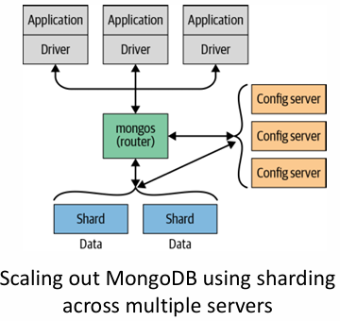

MongoDB dynamically balances data and loads throughout a cluster, redistributing documents as needed, and routing reads and writes to the appropriate servers (TutorialKart, n.d.)

Critical Evaluation

The results highlight MongoDB’s strength in handling semi-structured, high-ingest workloads such as tweets. Its schema flexibility and document model enable faster write and update operations. In contrast, MySQL is optimized for structured data with well-defined relationships, which can introduce overhead in write-heavy scenarios.
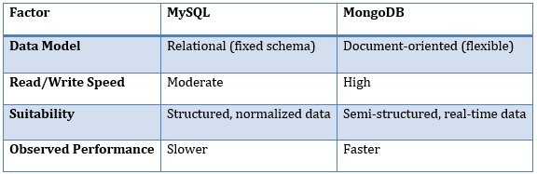

Conclusion

YCSB benchmarking shows that MongoDB outperforms MySQL in mixed workloads with a higher throughput and lower latency. This makes MongoDB better suited for dynamic, high-volume applications such as social media analytics, where performance and scalability are key. For this reason, MongoDB was chosen as the database layer. (Brian F. Cooper, n.d.) (Brian F. Cooper. 2010)

Big Data Architecture Design Discussion

Overview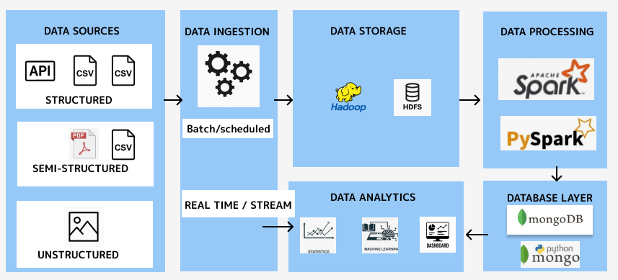
(Introduction to Big Data Architecture, 2022)
This architecture represents a modern and modular pipeline for processing data using distributed frameworks and NoSQL databases. It integrates Apache Hadoop for scalable storage, Apache Spark/PySpark for distributed processing, and MongoDB with PyMongo for NoSQL storage and Python-based access.
Component Breakdown

Data Sources
- Such as API feeds, CSV files (e.g., tweets, stock price data)
Why it works:
The model accounts for all real-world data types, allowing flexibility in ingestion and downstream analytics.

Data Ingestion
- Handles both Batch/Scheduled and Real-Time/Stream (refer to the final section of this report for a demonstration) ingestion using Spark.
Why it works:
This flexibility allows for combining historical data (batch) with up-to-date streams (real-time), essential for analytics on fast-changing datasets like tweets.
Data Storage – Hadoop & HDFS
- Hadoop Distributed File System (HDFS) is used to store raw and ingested data across distributed nodes.
Why it works:
HDFS provides scalable, fault-tolerant storage, making it ideal for handling high-volume datasets before they are processed.
Data Processing – Apache Spark & PySpark
- Apache Spark is used as the distributed processing engine for:
  - Loading and transforming data from HDFS
  - Performing joins, filtering, and aggregations
  - Running distributed computations and iterative ML workflows
- PySpark provides a Python interface for Spark, making it accessible to data scientists and analysts using Python.
Why it works:
PySpark enables distributed, in-memory processing of high-volume data, efficiently handling joins and transformations. It integrates seamlessly with HDFS for input and MongoDB for storing enriched outputs.
Database Layer – MongoDB & PyMongo
- MongoDB stores enriched, cleaned, or aggregated data, post processing.
- PyMongo is used for reading/writing to MongoDB collections from within Python or PySpark apps.
Why it works:
MongoDB’s flexible schema handles evolving tweet structures or nested fields. PyMongo allows fast integration with Python based analytics and web apps.
Data Analytics
- Analytics tools handle:
  - Statistical summaries (e.g., tweet volume, average prices)
  - Machine learning models (e.g., sentiment prediction)
  - Dashboards for business intelligence
Why it works:
MongoDB stores processed data for visualization and modeling, supporting insight-driven decisions. Note in this project, data was saved as CSV and exported locally for machine learning tasks due to VM resource limitations.

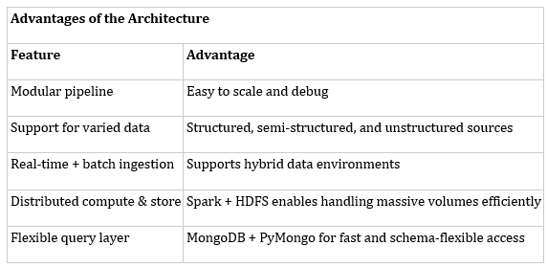
Summary
This architecture combines robust storage (HDFS), distributed processing (Spark/PySpark), flexible NoSQL persistence (MongoDB), and accessible Python integration (PyMongo). It supports a complete data journey, from ingestion to insight across data types and use cases.
Real-Time Big Data Use Case with Apache Spark and Reddit API
In this project it demonstrates a real-time analytics pipeline using Apache Spark (via PySpark) to load, stream, process, and perform real time analysis of data from a public API Reddit relating to stock and world news.
Below are screenshots that explain the implementation:
HDFS Upload Confirmation:
Processed post data written to Hadoop Distributed File System (HDFS) for scalable storage:

“Data uploaded to HDFS at: /user1/worldnews_posts_20250428_225838.json”

Confirmation of the JSON file being written locally and uploaded to Hadoop HDFS. This ensures long-term, distributed storage for scalability.
MongoDB Integration
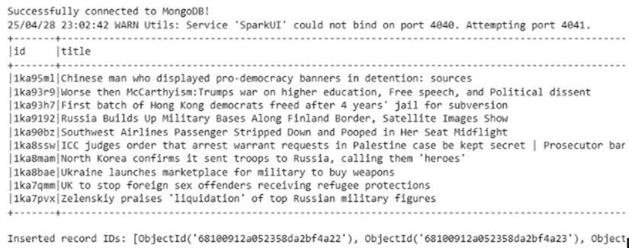
Posts are stored in MongoDB using PyMongo, providing fast and schema-flexible access for querying, dashboards, or further analysis. The output confirms successful document insertion.
Spark Word Frequency Output
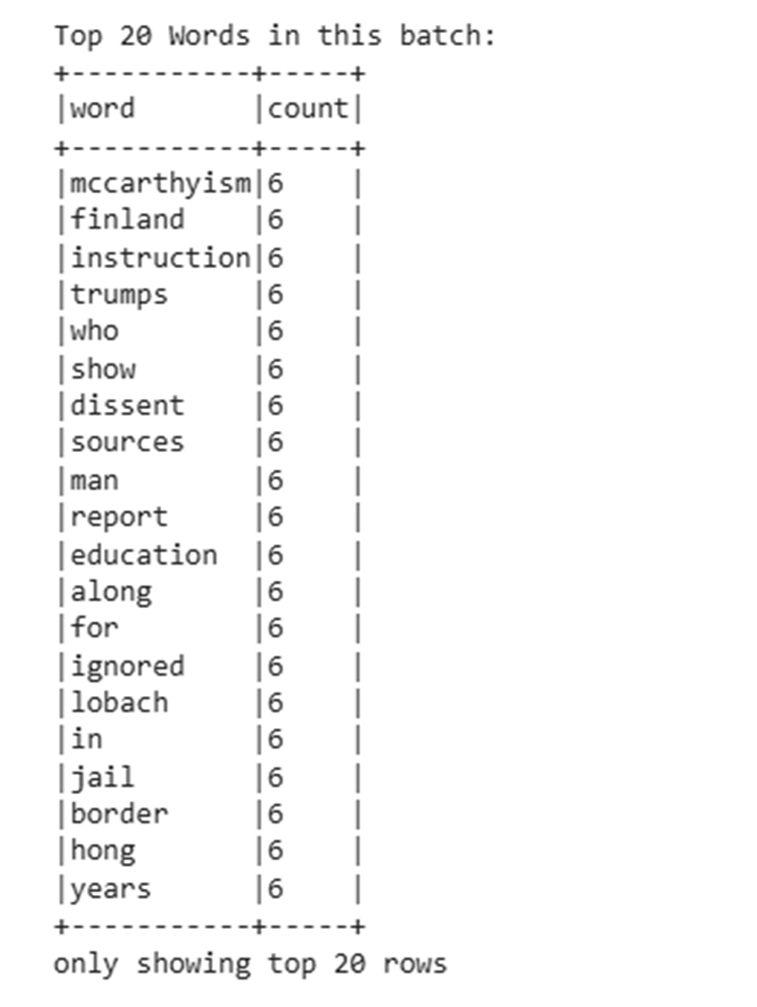
Output from PySpark showing the top 20 most frequent words after tokenization and stop word removal. Tokenization helps the NLP break down post content and stop word removal ensures your word frequency analysis and ML models emphasize relevant, topic-specific language.
The results reveal dominant topics being discussed in real-time Reddit posts from world news, such as 'McCarthyism', 'education', and 'border'.
Sentiment Analysis and Summarization
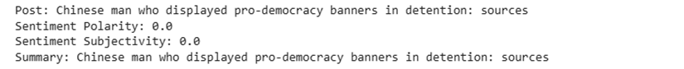
A post is analysed using TextBlob (the NLP) for sentiment polarity and subjectivity, followed by automatic summarization using a transformer model (hugging face). This enables real-time interpretation of the tone and content of each post. Posts with high positive polarity and high subjectivity might reflect optimistic speculation, while negative polarity with low subjectivity might indicate factual bad news.
Conclusion
This Spark-based pipeline ingests and analyses Reddit data in real time, applying NLP tasks like sentiment analysis and summarization, with results stored in MongoDB and HDFS. It enables live trend detection and enhances forecasting by integrating real-time news, demonstrating a scalable, end-to-end NLP solution with PySpark.

Advanced Data Analytics

This project aims to forecast stock prices by combining historical price data with tweet-based sentiment analysis, using two different model types, the SARIMAX autoregressive model and LSTM deep learning model.
The Exploratory Data Analysis (EDA) process began with selecting 5 tickers from the 41 available. Stock price files were combined, and companies with a full year of data (254 rows) were retained. From the tweet dataset, companies were chosen based on the number of days with tweet activity, prioritizing consistency over total tweet volume.
This ensures:
- Temporal Alignment: Models like LSTM and SARIMAX need evenly spaced data to avoid skewed trends.
- Reduced Volume Bias: Avoids overfitting to short-term tweet spikes unrelated to real events.
- Stronger Sentiment Signals: Consistent activity yields more stable and meaningful sentiment features.

Based on this process the 5 companies chosen were Apple (AAPL), Amazon (AMZN), Boeing (BA), Disney (DIS), and Tesla (TSLA).
Data wrangling was applied to clean and prepare the tweets dataset for modelling. This included converting emojis into English text descriptions to enhance the sentiment model’s ability to detect emotional tone. Stop words (low-information words) like "and" were removed to reduce noise and improve NLP accuracy. Finally, tokenization was used to break down sentences into smaller units, making the text suitable for our NLP.
(Jurafsky and Martin, 2021)

The tweets were prepared for sentiment analysis. FinBERT was initially considered but underperformed on informal Twitter data. VADER, designed for social media text, proved more effective, particularly in handling slang. It generated a compound sentiment score for each tweet, ranging from -1 negative to +1 positive.
(GeeksforGeeks, n.d.)

Since multiple tweets may exist per day per company, daily averages of compound scores were calculated. This transforms noisy individual tweets into a more stable daily sentimental signal to align with daily stock price movements.

VADER performs well overall but struggles with newer slang and nuanced or sarcastic emojis. Most stock related tweets show a bullish bias (54% positive), likely reflecting personal investment interests over objective analysis. Future improvements could involve training models on professional financial media with clearer, more precise language.
(CodeProject, n.d.)

For autoregression, the compound score was left-joined with stock prices to preserve the dependent variables full time series while adding sentiment data where available. The numeric compound score was used instead of sentiment labels, as autoregressive models require continuous variables.

After further analysis we chose the SARIMAX model as the autoregressive model for the following reasons:

- Seasonality: Weekly patterns in stock prices were identified, which SARIMAX models well with seasonal components.
- Exogenous Variables: SARIMAX integrates sentiment scores, enhancing forecasts by accounting for public sentiment.
- Non-Stationarity: The ADF test showed non-stationarity, addressed through differencing (d=1) in SARIMAX.
- Performance: The model showed solid predictive accuracy, capturing both trends and short-term fluctuations.

For the neural network the LSTM model was chosen for its strength in recognizing long-term patterns and relationships in time-series data makes it well suited for predicting future movements in the financial markets. (Zhang, 2024)
Utilising LSTM’s abilities, the average compound score was taken, categorised, one hot encoded and then joined with stock price. The LSTM model was chose for the following reasons:
- Model Fit: LSTM handles categorical inputs better than nuanced numerical scores.
- Avoiding Compound Ambiguity: The compound score, while continuous, can be noisy and harder to interpret consistently across time and tickers.
- Event Detection: One-hot encoding highlights distinct sentiment shifts more clearly than subtle changes in a single score.
- Clarity: One-hot encoding sentiment labels (Positive, Neutral, Negative) improves interpretability by clearly showing the impact of each class.
- Performance: The model showed solid predictive accuracy, capturing both trends and short-term fluctuations.
(Alooba, n.d.)
To prepare the dataset for modelling with SARIMAX, first missing sentiment data was filled in using fill forward and backwards to maintain data continuity, minimize loss, and preserve the temporal structure of the dataset without distorting sentiment trends. Then we first differenced the dataset’s dependent variable (stock prices). Time series models assume that the statistical properties of the data mean, variance, and autocorrelation remain constant over time. This is called stationarity. If the data is not stationary, the model’s predictions can become unreliable or biased.
We used ACF and PACF plots on the adj_close price to identify the AR and MA components of the SARIMAX model.
- ACF captures overall correlation with lagged values and informs the MA term (q).
- PACF shows direct correlation by removing shorter lags’ influence and informs the AR term (p).
Accurately selecting p and q ensures the model captures the underlying time dependencies.
SARIMAX hyperparameter tuning
Manual tuning was used for the SARIMAX model after GridSearchCV produced similar results with limited interpretability. This approach allowed for a clear justification of parameter choices, based on the degree of differencing, ACF/PACF plots, and observed seasonality.
Given the stock prices exhibited weekly seasonality (five trading days), a seasonal period of 5 was selected. The Augmented Dickey-Fuller test confirmed non-stationarity, while ACF and PACF plots guided the selection of the AR (p), I (d), and MA (q) parameters i.e. the hyperparameters.
LSTM
To prepare the merged dataset for LSTM modelling, the distribution of each ticker's data was analysed using sns.pairplot for visualisation and .describe() for summary statistics. The results showed non-normal distributions and significant variation between minimum and maximum adj_close values. As a result, MinMax Scaler was applied to normalise the data, ensuring all features were on a comparable scale for effective LSTM training.
LSTM hyperparameter tuning and model design
- GridSearchCV for Hyperparameter Selection
  - GridSearchCV was applied to identify optimal values for:
    - Batch size (8, 16)
    - epochs (50, 100)
    - model units (32, 50, 64)
  - The best parameters were extracted and used in final training.
- Manual Tuning of Time Step (Sequence Length)
  - A manual search was conducted to evaluate different time steps: 3, 5, and 10 days.
  - Based on model performance and predictive accuracy, a 5-day sequence was selected as the most effective window for capturing short-term temporal patterns in stock price and sentiment data. As Identified in SARIMAX pre-processing.
- Transfer Learning Across Tickers
  - Pretrained LSTM models were reused across tickers and fine-tuned on new datasets to improve efficiency and leverage previously learned temporal structures.
(Simplilearn, 2022)
Justification of the Approach
- GridSearchCV offered a structured way to identify the best-performing hyperparameters, crucial when working with a short time series where overfitting is a risk and training data is limited.
- Data Augmentation: Manually evaluating time steps (3, 5, 10 days) allowed for fine control over how much past data was used to predict the future. A 5-day window proved optimal, offering enough context without overloading the model with limited data.
- Efficiency and Adaptability: Transfer learning helped overcome the constraints of short datasets by leveraging knowledge from models trained on similar tickers, effectively boosting learning without requiring large volumes of new data.
(Smith, n.d.)
Presentation of Results and Dashboard Evaluation Based on Tufte’s Principles
In the final stage of this project, results were presented through a dynamic dashboard which incorporated predictions from both models for Days 1, 3, and 7 stock price forecasts, for each company. Along with the actual results for a performance comparison for each company.
I’ve also included a table in this report for convenience:
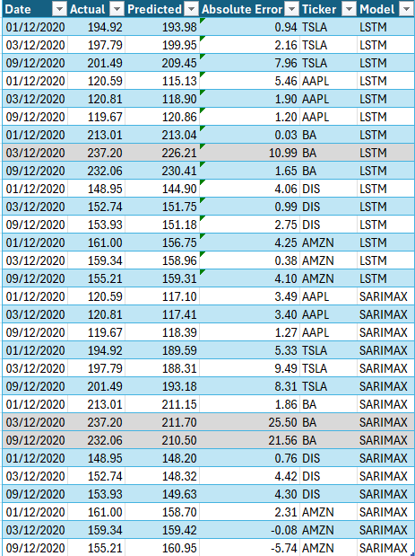
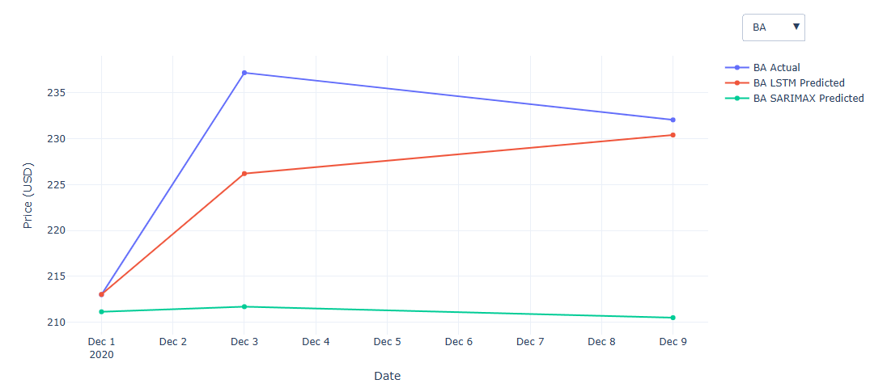
Discussion of Tufte’s Principles in the Dashboard
Edward Tufte's principles of data visualization emphasis clarity, integrity, and efficiency. Here’s how the dashboard aligns with these principles:
- Data-Ink Ratio: The visualizations minimized unnecessary graphical elements (e.g., no grid clutter or excessive labels), focusing instead on the data itself, aligning with Tufte’s goal of maximizing the “data-ink” ratio.
- Chart junk Elimination: The dashboard avoided decorative or non-informative graphics. Plots were direct and minimal, supporting Tufte’s rule to avoid “chart junk.”
- Small Multiples: While not used explicitly, the presentation of results across multiple time horizons (1-day, 3-day, 7-day) acted like small multiples, showing consistent structure across multiple data slices for easy comparison.
- Integration of Words, Numbers, and Images: Although textual captions were limited in the notebook, the tabular summaries with numerical output next to plots reflect Tufte’s recommendation to place explanatory content close to the visuals for immediate context.
- Comparisons and Causality: The dashboard supported comparison between predicted vs. actual stock prices, allowing users to draw meaningful conclusions about model performance and short-term trends.
(Tufte, 2001)

Overall Accuracy
- LSTM consistently showed lower absolute errors across most stocks and dates.
- SARIMAX errors were generally higher, with some extreme deviations especially for volatile stocks like BA and TSLA.
Example (BA on 03/12/2020):
- LSTM Error: 10.99
- SARIMAX Error: 25.50
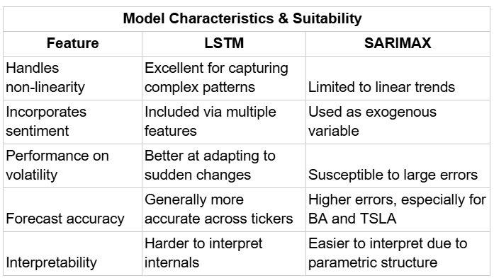
Conclusion
LSTM clearly outperformed SARIMAX in most scenarios, especially when handling volatile or non-linear stock movements. While SARIMAX offers interpretability and is useful for stable, seasonal trends, LSTM’s flexibility and ability to incorporate multiple features make it the more suitable choice for short-term stock forecasting using financial and sentiment data.

References

Alooba. (n.d.). One-hot encoding. Available at: https://www.alooba.com/skills/concepts/data-science/one-hot-encoding/ (Accessed: 22 May 2025).

Brian F. Cooper, Adam Silberstein, Erwin Tam, Raghu Ramakrishnan, Russell Sears (Yahoo! Research), SoCC’2010
https://people.cs.uchicago.edu/~junchenj/34702/slides/YCSB.pptx

Brian F. Cooper (n.d.) YCSB - Yahoo! Cloud Serving Benchmark. [GitHub] Available at: https://github.com/brianfrankcooper/YCSB [Accessed 22 May 2025].

Brian F. Cooper (n.d.) YCSB - Yahoo! Cloud Serving Benchmark. [GitHub] Available at: https://github.com/brianfrankcooper/YCSB/tree/master/mongodb [Accessed 22 May 2025].
CodeProject (n.d.) Pros and Cons of NLTK Sentiment Analysis with VADER. Available at: https://www.codeproject.com/Articles/5269447/Pros-and-Cons-of-NLTK-Sentiment-Analysis-with-VADE (Accessed: 22 May 2025).

Cooper, B. F., Silberstein, A., Tam, E., Ramakrishnan, R., & Sears, R. (2010). Benchmarking cloud serving systems with YCSB. In Proceedings of the 1st ACM symposium on Cloud computing (pp. 143–154).
https://doi.org/10.1145/1807128.1807152

Demoji (n.d.) Demoji 1.1.0. Available at: https://pypi.org/project/demoji/ (Accessed: 20 May 2025).

GeeksforGeeks (n.d.) Python Sentiment Analysis using VADER. Available at: https://www.geeksforgeeks.org/python-sentiment-analysis-using-vader/ (Accessed: 22 May 2025)

Introduction to Big Data Architecture, Software Architecture Academy, Mar 29, 2022 [Accessed 18 May 2025].

https://www.youtube.com/watch?v=rvqCqK2Lpjg

Jurafsky, D. and Martin, J.H. (2021) Speech and Language Processing: An Introduction to Natural Language Processing, Computational Linguistics, and Speech Recognition. 3rd edn (draft). Stanford, CA: Stanford University

Simplilearn (2022) Sentiment Analysis Using NLP | NLP Projects | Natural Language Processing Tutorial | Simplilearn, YouTube. Available at: https://www.youtube.com/watch?v=BqqfQnyjmgg (Accessed: 22 May 2025).

Smith, H. (n.d.) How to overcome the challenges of small data in neural networks, LinkedIn. Available at: https://www.linkedin.com/pulse/overcome-challenges-small-data-neural-networks-hayden-smith/ (Accessed: 22 May 2025).

Tufte, E.R. (2001) The Visual Display of Quantitative Information. 2nd edn. Cheshire, CT: Graphics Press.
https://doi.org/10.1198/tech.2002.s78

TutorialKart (n.d.) MongoDB Tutorial. [Online] Available at: https://www.tutorialkart.com/mongodb/mongodb-tutorial/ [Accessed 12 May 2025].
TutorialsPoint (n.d.) Apache Hadoop Architecture Explained with Diagrams. [Online] Available at: https://www.tutorialspoint.com/apache-hadoop-architecture-explained-with-diagrams [Accessed 12 May 2025]

Zhang,J. (2024). Analysis of stock forecasting based on LSTM. Applied and Computational Engineering, 51,196-201
https://doi.org/10.54254/2755-2721/51/20241345

Screencast
https://drive.google.com/drive/folders/1YmYPEmpA1aYIyJO6Iwm79MQ3FNaWH4rT?ths=true

